**Searching for string**

**What is a searching for string?**

Searching for strings in JavaScript involves looking for specific sequences of characters within a larger text. Here's an explanation with examples and their outputs, using basic English language:

1. **Finding a Substring within a String:**

Let's say we have a string "Hello, world!". We want to check if it contains the substring "world".

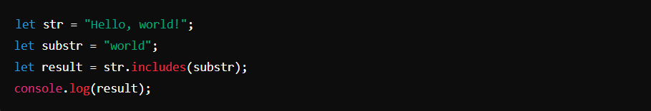

**Output:**



**Explanation:**

* In this example, **includes()** method checks if the string **str** includes the substring **substr**.
* Since "world" is indeed part of "Hello, world!", the output is **true**.

1. **Finding the Position of a Substring**

Now, let's find the position of the substring "world" within the string "Hello, world!".

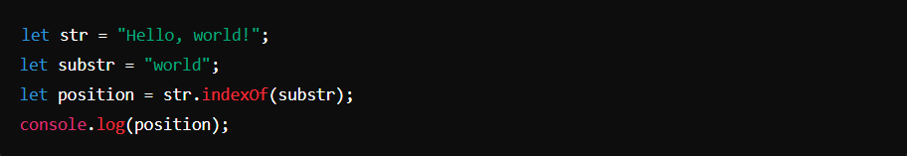

**Output:**



**Explanation:**

* The **indexOf()** method returns the position of the first occurrence of the substring within the string.
* In "Hello, world!", "world" starts at index 7 (JavaScript strings are zero-indexed), so the output is **7**.

1. **Searching with Regular Expressions:**

Regular expressions provide powerful tools for string search patterns. Let's use a regular expression to find all occurrences of the word "apple" in a string.

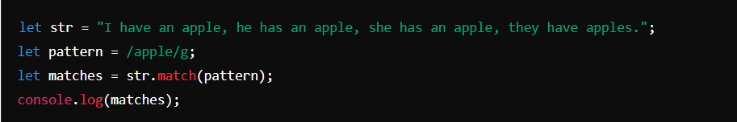

**Output:**



**Explanation:**

* The **/apple/g** is a regular expression pattern that matches all occurrences of "apple" in a string or in other words it searches globally all **apples**.
* The **match()** method returns an array containing all matches found.
* In the given string, "apple" appears three times, so the output is an **array ["apple", "apple", "apple"].**